Exercise No. : 2

Date : 14/10/2020

**AIM:**

ToWrite a Python function countX (lst, x) to count the number x in a given list of numbers.

**PROGRAM:**

def countX(list,s):

c = 0

for i in range(0,len(list)):

if(list[i] == s):

c += 1

print("\n")

print(c)

list = []

x = int(input("enter the array size: "))

for i in range(0,x):

list.append(int(input()))

s = int(input("enter the number to find: "))

countX(list,s)

**LINK:**

[**http://103.53.53.18/mod/vpl/forms/edit.php?id=230&userid=1639**](http://103.53.53.18/mod/vpl/forms/edit.php?id=230&userid=1639)

**OUTPUT:**

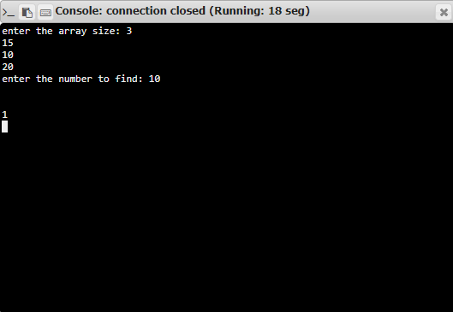

**RESULT:**

The program has been successfully executed and verified.